Population Growth Name: ____________________________
Objective:Students will be able to identify limiting factors in order to describe how these factors affect the growth and decline of populations.
THE LYNX AND THE HARE
The Hudson Bay Trappers was a group of smaller companies that worked in the fur business during the 1700s. As a group, they caught different animals, and shipped the pelts, particularly those of lynx and snowshoe hares, from America to Europe. The trappers kept records of the number of pelts they shipped over hundreds of years. A study of their records shows a distinct relationship between the populations of lynx and snowshoe hares. First, the trappers noted that the snowshoe hare populations seemed to increase for a period of about 7 years, and then it would fall for a period of about 7 years. The trappers noted that the lynx population would do the same thing - except that the lynx would peak and crash about one year after the hare populations. So, it would rise for about 8 years and then
bottomed out about a year after the snowshoe hare population. This same trend was noted throughout fifty years of records kept by the Hudson Bay Trappers.
2. Complete the statements identifying changes in the lynx and snowshoe hare populations.The snowshoe hare population increased for a period of ____ years.
The snowshoe hare population decreased for a period of _____ years.
The lynx population peaked before/after the snowshoe hare population.
The lynx population bottomed out before/after the snowshoe hare population.
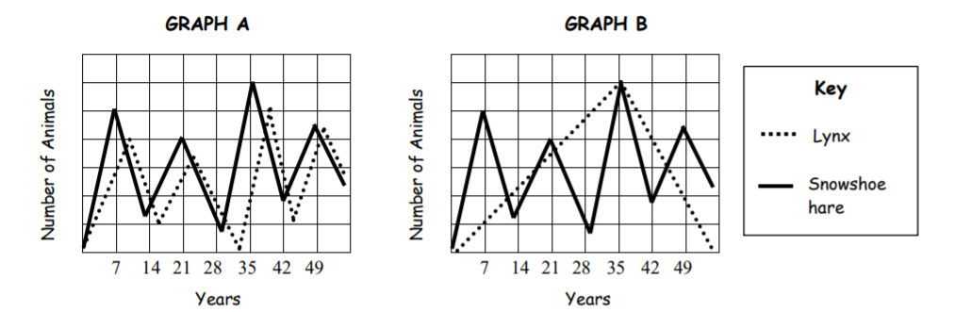
4.I think graph ______ would most likely represent the changes in the lynx and snowshoe hare populations because___________________________________________ ______________________________________________________________ ______________________________________________________________

Activity 2: Survival is a Roll of the Dice. Working with a partner, you will roll 2 dice at the same time and use the table below to simulate changes in the owl population six months at a time. At the end of each year (after 2 rolls), you will total the owl population.
TABLE 1: EFFECT ON THE OWL POPULATION
If you roll: | You should: | Reason
Double 2s, 3s, 4s, or 5s | Subtract 3 | Nest made too close to ground; eggs raided by weasels; three eggs taken.
2 | Divide by 2 (round down) | Disease kills half the population.
3 | Do nothing right now; do not add eggs next year | Food shortage occurs.
4 (1+3) | Subtract 1 | One owl dies of natural causes.
5 | Subtract 1 | Owl killed by another owl in a fight over food.
6 (2+4 or 1+5) | Add 1 | Owl population lives well for 6 months.
7 or 12 | Add 3 | Local farmer builds nesting boxes to encourage owl breeding on area farm.
8 (2+6 or 3+5) | Subtract 1 | One fledgling dies.
9 | Subtract 2 | Drought in the area; two owls leave area.
10 (4+6) | Subtract 3 | Local timber company cuts down half of the trees in the ecosystem.
11 | Subtract 1 | Pesticides from local farm cause egg shells to become thin.
ADJUSTING FOR MATURATION AND REPRODUCTION
Maturation | Owls typically do not stay together in groups. Subtract four owls if your population is higher than ten when you calculate your SUBTOTAL. Adjust the number of beans accordingly.
Reproduction | Add four eggs at the beginning of each year UNLESS there is a food shortage the previous year. Adjust your beans accordingly.
Activity 3: Hmmm… What Happened in that Activity?
1. Briefly describe what happened to your population of owls over the course of the activity. (*Hint: Did the population increase? Did it decrease? Both? Did it survive? Die out?)
__________________________________________________________________ __________________________________________________________________ __________________________________________________________________
2. Identify 2 reasons why your owl population INCREASED during the activity.
______________________________________________________________
______________________________________________________________
3. Identify 2 reasons why your owl population DECREASED during the activity. ______________________________________________________________ ______________________________________________________________
4. Identify 2 times the owl population experienced competition for resources.
_____________________________________________________________
_____________________________________________________________

YEAR | LAST  YEAR’S TOTAL | ADD  MORE  EGGS  (+4) | FIRST 6 MONTHS |  | SECOND 6 MONTHS |  | OWL  SUBTOTAL | SUBTRACT OWLS? | TOTAL  POPULATION FOR THE  YEAR
YEAR | LAST  YEAR’S TOTAL | ADD  MORE  EGGS  (+4) | REASON | EFFECT ON  OWLS | REASON | EFFECT ON  OWLS | OWL  SUBTOTAL | SUBTRACT OWLS? | TOTAL  POPULATION FOR THE  YEAR
1 | 2 | +4
2
3
4
5
6
7
8
9
10
11
12
13
14
15

